Kerry: Israel agrees to round the clock surveillance at Temple Mount, committed to status quo
US secretary of state: Netanyahu has agreed to 24-7 video surveillance in Jerusalem's al-Aqsa compound, Israeli officials and Waqf authorities soon to meet to discuss meeting tensions.
Itamar Eichner and Elior Levy
Published: | 10.24.15, 16:42 / Israel News

US Secretary of State John Kerry said on Saturday that Israel and Jordan have agreed on steps aimed at reducing tensions at a holy site in Jerusalem that have fanned Israeli-Palestinian violence. Kerry said Netanyahu had expressed a commitment to continue enforcing the status quo, which says only Muslims may pray at the compound, while non-Muslims may only visit.

- Follow Ynetnews on Facebook and Twitter

"All the violence and the incitement to violence must stop. Leaders must lead," Kerry told reporters

Jordan is custodian of the site known to Jews as the Temple Mount and to Muslims as the Noble Sanctuary.

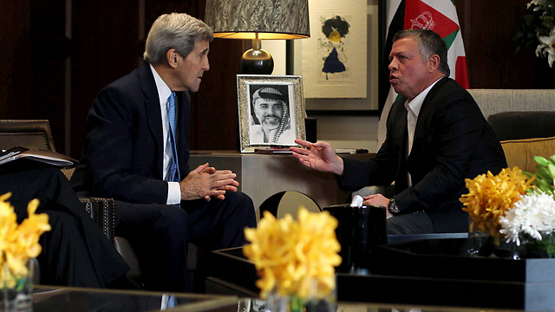
John Kerry and Jordanian King Abdullah II in Amman (Photo: Reuters)

Kerry said the steps include round-the-clock video monitoring and Israel's reaffirming of Jordan's special and historic role as custodian.

An Israeli government source told Ynet that Israel has an interest in installing cameras in the Temple Mount in order to disprove claims that Israel is changing the status quo. In addition, said the source, Israel wants to show that provocations are not started by the Israeli side.

Kerry added that Israeli and Jordanian authorities will meet about bolstering security.

Outlining the series of understandings, Kerry said:

Israel "fully respects" Jordan's "special role" as custodian of the site.

Israel will continue to enforce its policy of religious worship, including "the fundamental fact" that it is Muslims who pray there and non-Muslims who visit.

Israel has no intention of dividing the site and rejects any attempt to suggest otherwise.

Israel welcomes increased coordination between Israeli authorities and Jordan to ensure that visitors and worshippers "demonstrate respect and restraint."

Noting the video monitoring, Kerry said it would provide "comprehensive visibility and transparency, and that could really be a game-changer in discouraging anybody from disturbing the sanctity of this holy site."

"Israel will continue to enforce its long-standing policy on religious worship ... at the Temple Mount/Haram al-Sharif, including the fundamental fact that it is Muslims who pray on the Temple Mount/Haram al-Sharif, and non-Muslims who visit," Kerry added.

"I hope that based on these conversations we can finally put to rest some of the false assumptions, perceptions" about the holy site, Kerry said. "Those perceptions are stoking the tensions and fueling the violence and it is important for us to end the provocative rhetoric and start to change the public narrative that comes out of those false perceptions."

It should be noted that Israel strongly opposed a recent French initiative to place international observers at the Temple Mount, a proposal that led to the French ambassador being reprimanded by the Foreign Ministry in Jerusalem.

The hilltop compound is a frequent flashpoint and its fate is a central issue at the heart of the Israeli-Palestinian conflict.

Kerry made the announcement after meeting in Jordan's capital King Abdullah II and Palestinian leader Mahmoud Abbas.

Saeb Erekat, the secretary general of the PLO Executive Committee, said that during the meeting with Kerry, the Palestinian leader asked for the formation of an international investigative committee regarding escalation of the Israeli-Palestinian conflict.

According to Erekat, Abbas was told by Kerry that Netanyahu had agreed to freeze building in West Bank settlements.
Kerry had met with Netanyahu in Berlin on Thursday.

The news agencies contributed to this report.

Here is another version of this story: http://www.nytimes.com/2015/10/25/world/middleeast/israel-and-jordan-agree-on-steps-to-ease-jerusalem-tensions-kerry-says.html?_r=0

